We focus on the medium product backlog items first and we follow the estimates.

Laura:

9 - As a cashier, I want to accept an order when a payment is in cash so that it will appear for baristas.

Kamil:

8 - As the display monitor, I want to fetch and display both pending and completed orders for customers to know the status of their order.

Robert:

10 - As a customer, I want to be prompted for extras to put in my drink (like syrups) so that my coffee will be more tasteful.

12 - As a customer, I want to be able to cancel my order at any time so that I am free to make that decision.

**SPRINT GOAL:** Two or three new windows - for a cashier, proxy for the different users, Display view, view or prompt for extras,

| PB-ID | ID | Task Title | Responsible | Estimate (hours) | Status |
| --- | --- | --- | --- | --- | --- |
| 8 | 1 | Design and Create Display View | Kamil | 8 | Completed |
| 8 | 2 | Implement VC and VM for Display | Kamil | 8 | Completed |
| 8 | 3 | Document and test Display | Kamil + Robert | 16(8*2) | Completed |
| 9 | 4 | Design and Create Cashier View | Laura | 4 | Completed |
| 9 | 6 | Implement VC and VM for Cashier View | Laura | 8 | Completed |
| 9 | 5 | Document and test Cashier | Laura | 4 | Completed |
| 9 | 7 | Implement VC and VM for - access keys | Daniel | 16 | Completed |
| 10 | 8 | Implement ExtraView with four different types | Robert+Kamil | 14 | Completed |
| 10 | 9 | Design ExtraView | Robert+Kamil | 2 | Completed |
| 10 | 10 | Document and test Extra | Robert | 2 | Completed |
| 12 | 11 | Implement the quit button | Daniel | 10 | Completed |

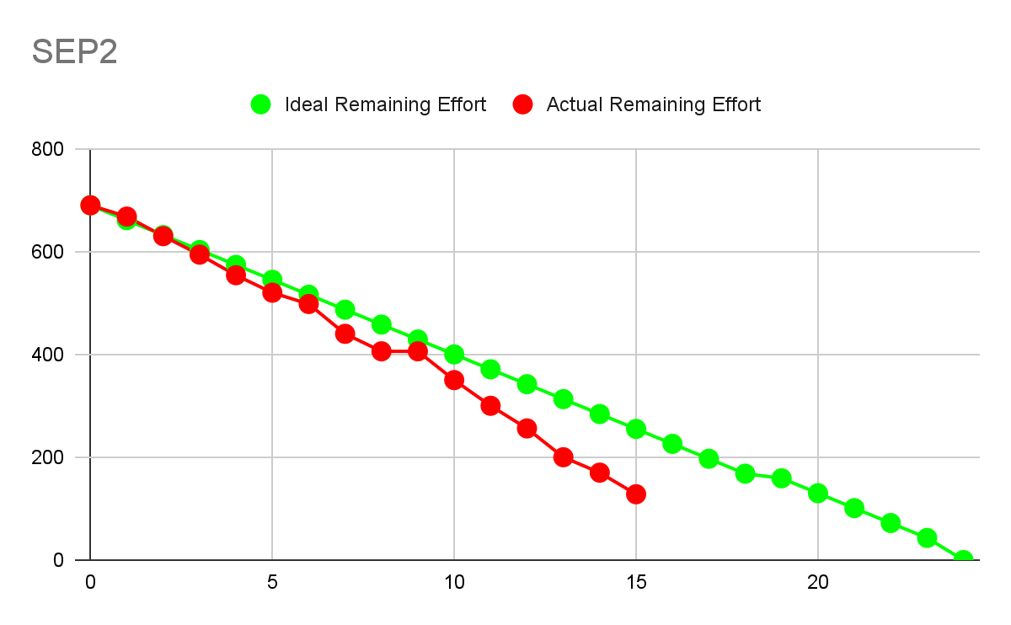

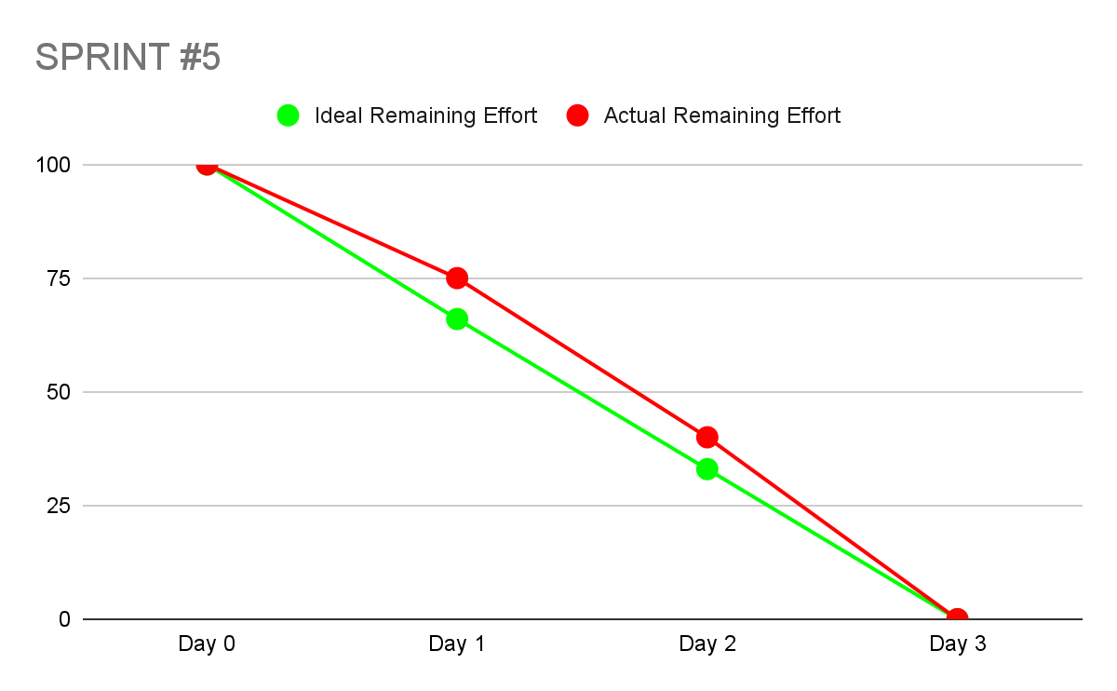

**WHAT WAS ACHIEVED:**

* LAURA: Implemented the whole Cashier view with proper documentation
* KAMIL: Implemented the Display View with Observer Pattern in RMI, helped with the implementation about adding extras to the item.
* DANIEL: Implemented Managing of Access Keys - the window and the functionality
* ROBERT: Implemented the extras, + their addition and removal in the extra view

**WHAT WENT WELL:**

* LAURA: Went to a room alone, got inspired and did documentation really fast. It felt good and effective.
* ROBERT: Found things that were missing during the integration testing and created a new product backlog to further improve the system
* KAMIL: The display works with the Observer and the documentation is very solid.
* DANIEL: It’s working

**WHAT TO DO NEXT:**

* LAURA: start doing javadoc, start thinking about what the reports will look like, finish the rest of the implementation quickly :) most of the system is already down!
* LAURA: Implement listeners in Barista - kamil please >.<
* KAMIL: Focus on implementation, documentation and cleaning up the code.
* ROBERT: maybe javadoc, one day
* DANIEL: document my work from this sprint